DRAFT Obey Creek Development Agreement
Last revised: January 7, 2015

The following document is a draft version of the Obey Creek development agreement. The purpose of this document is to provide an overview of the conversations held thus far in the Obey Creek development agreement process and to provide an outline of a development agreement document.

This document is based upon the outline of topics that was reviewed by the Council during the Obey Creek Special Meeting on November 13, 2014. For a link to these topics, click here.

Attachment A to this document includes the enabling legislation from the North Carolina State Statues for development agreements.

The Glen Lennox Development Agreement was used as a template for this document. For more information about the Glen Lennox Development Agreement, click here.

For more information about the Obey Creek development agreement process, visit www.townofchapelhill.org/obeycreek

This document is a draft version and is a living, dynamic document that will change throughout the Obey Creek development agreement process.

This document was last revised on:
January 7, 2015

DEVELOPMENT AGREEMENT

BY AND BETWEEN

OBEY CREEK VENTURES, LLC.
C/O EAST WEST PARTNERS MANAGEMENT COMPANY, INC.

AND

THE TOWN OF CHAPEL HILL, NORTH CAROLINA

Effective Date: _______, 2015

Orange County Parcel Identifier Numbers: 9787-13-6437; 8787-14-0366; 9787-14-8639;
[OBEY CREEK: Insert additional PINS, as necessary]

Table of Contents
Page
Article 1. STATUTORY FRAMEWORK X
Article 2. DEFINITIONS X
Article 3. RECITALS X
Article 4. TERMS X
Article 5. SPECIFIC STANDARDS AND MITIGATION MEASURES X
EXHIBITS INCORPORATED BY REFERENCE
[OBEY CREEK: Insert Exhibits]
STATE OF NORTH CAROLINA  COUNTY OF ORANGE | DEVELOPMENT AGREEMENT

This Development Agreement (hereinafter the “Agreement”) is made and entered into as of the ____ day of ____ 2015 by and among Obey Creek Ventures, LLC. C/O EWP, NC (“Obey Creek Ventures”) and the Town of Chapel Hill, North Carolina, a municipal corporation of the State of North Carolina.

STATUTORY FRAMEWORK

[OBEY CREEK: This section will contain an overview of the legal framework and authorizations by the North Carolina General Statutes for development agreements. This section is under review by the Town Attorney and staff to revise as necessary.]

DEFINITIONS

[OBEY CREEK: This section will contain definitions that are pertinent to this development agreement. This section is under review by the Town Attorney and staff to revise as necessary.]

RECITALS

[OBEY CREEK: This section will contain an overview of the background of the Obey Creek process. This section is under review by the Town Attorney and staff to revise as necessary.]

TERMS

[OBEY CREEK: This section will contain the legal terms to which the Town and the developer agree. This section is under review by the Town Attorney and staff to revise as necessary.]

SPECIFIC STANDARDS AND MITIGATION MEASURES
[OBEY CREEK: This section contains the specific standards to which the Obey Creek development will be developed. The following information is an overview of the topics that the Council has discussed thus far in the process; we anticipate continued discussions on each of these items. This section also contains an overview of the topics that are under review by staff. This section will be revised and edited throughout the Obey Creek development agreement process.]

The Parties do hereby agree to the specific standards and mitigation measures set forth in this Section.

Scale of Development and Uses Permitted.

The scale of development for the Property shall be consistent with the Land Use, Height, and Density provided for in [OBEY CREEK: Insert Exhibit – Reference the Building Typologies map, type, and height information from the Design Guidelines document – Click here for document]

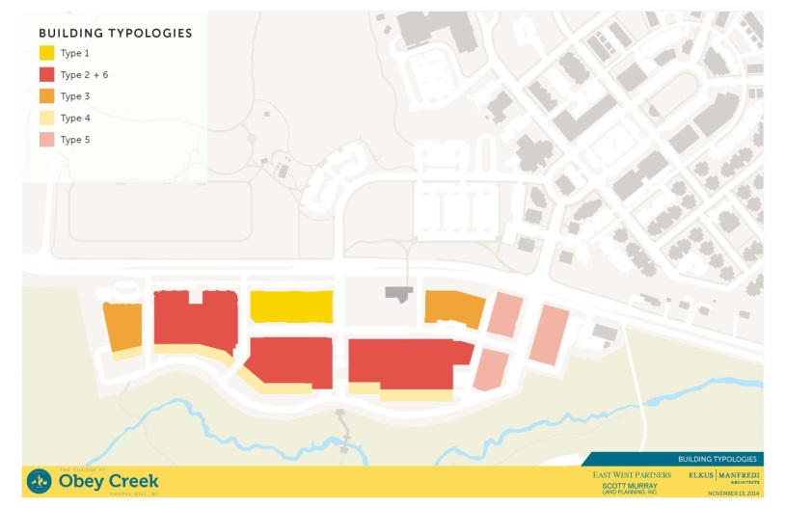

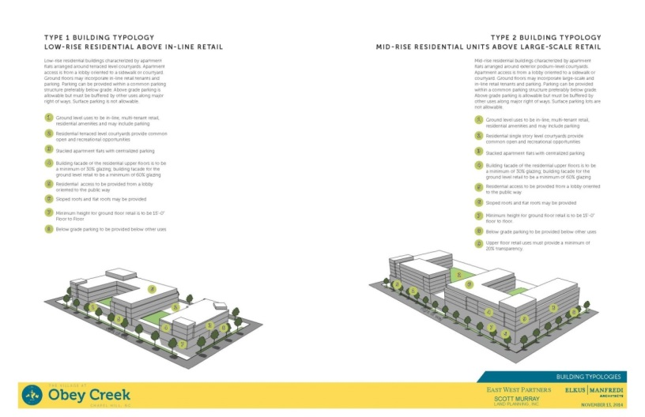

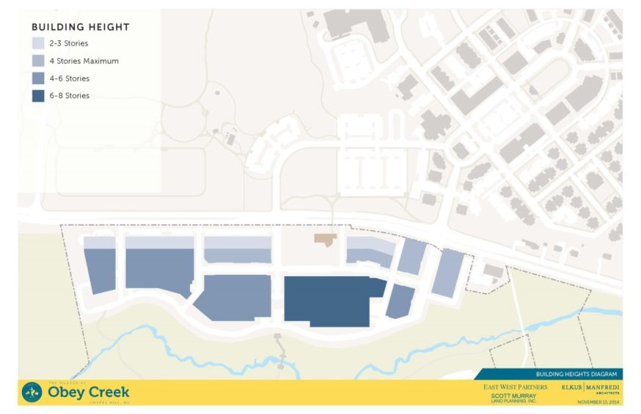

The land uses permitted by this Agreement are limited to those as listed in [OBEY CREEK: Insert Exhibit – See information below.]
The following provides an overview of the minimum and maximum amounts of development proposed by the Obey Creek concept plan. This information was provided by the applicant during the November 13th Obey Creek Special Meeting and can be found here.

Proposals | Use and Floor Area
 | Total Floor Area | Residential | Commercial/Retail | Office | Hotel
Minimum | 640,000 sq. ft. | 250 units  290,000-330,000 sq. ft | 200,000 sq. ft. | 150,000 sq. ft. | N/A
Maximum | East West Partners has agreed to not exceed  1.6 million sq. ft. | 800 units  Sq. ft. not specified | 475,000 sq. ft. | 600,000 sq. ft. | 400 rooms and ancillary space

Phasing
The following is the phasing plan proposed by East West Partners:

No individual building or phase of buildings shall be required to include any particular use except as required by the Design Guidelines. Prior to the approval of each new building, the developer shall be required to show that the remaining undeveloped portions of the site are sufficient to provide for the minimums of each use within the project Design Guidelines and probable future location of those uses. Developer shall also show that the minimums for each use can be accomplished without triggering any other limiting factors below.
Limiting Factors
The following limiting factors were developed by East West Partners:

In addition to square footage and/or unit count, other limiting factors to the maximum amount of development shall include:
- Prescribed building height maximums
- Impervious surface limitations
- Daily Automatic trip generation
- AM Peak hour automobile trip generation
- PM Peak hour automobile trip generation

Affordable Housing.
[OBEY CREEK: During the December 8, 2014 Obey Creek Special Meeting, the Council established a committee, consisting of Councilmembers George Cianciolo, Sally Greene, and Jim Ward, to develop proposals for affordable housing options for the Council’s review. The committee was asked to provide an update to the Council during the January 8, 2015 Obey Creek Special Meeting.]

Obey Creek is committed to the promotion of workforce and affordable housing on in the larger Chapel Hill community. Below are several strategies to be pursued to provide affordable and workforce housing. The final affordable housing component of Obey Creek could incorporate one or more of these strategies.

For-Sale Housing: Any housing offered for sale (whether sold at first occupancy or as a condo conversion) shall meet the 15% Inclusionary Zoning Ordinance through the provisions of units, payment in lieu of units, or any combination thereof. Any prior payments made on behalf of rental units would apply to the requirements upon a condo conversion.

Middle Income Rental Housing: A portion of rental units can be rent controlled to guaranty affordability at the 80%, 100% and 120% AMI levels. Affordability would be defined as rent set at 30% of gross income. Single and double occupancy households would be offered 1 bedroom units and triple occupancy or higher would be offered 2 bedroom units.

Agency Partnerships: We have been in conversation with affordable housing agencies to provide subsidized housing. CASA and The Arc of the Triangle have expressed an interest in securing units within residential development at Obey Creek to provide units for their clients. The owner of the apartment building would enter into a lease of units with the Agency who would in turn manage the leasing and maintenance of those units.

Rental Payments in Lieu: A payment in lieu of rental units could be made to the Town’s Affordable Housing Fund to subsidize affordable housing off-site.

Annual Report. The annual report will include cumulative information about the for-sale and rental affordable units in the Project, how affordability is being monitored, and data about the rental program for Vested Renters, including income level and rent levels for the affordable rental units and the total number of rental units built each year.

Stormwater Management.

[OBEY CREEK: This section is under review by the Town Attorney and staff to revise as necessary.]

Transportation: Transit, Parking, Streets, Sidewalks, and Bikeways.

[OBEY CREEK: This section will be revised throughout the process.]

General Provisions.

All new [OBEY CREEK: Edit as necessary - and rebuilt]roads and streets within the Property that may support public transit in the future shall be designed and constructed to meet Town standards for roads that support such use as of the Effective Date unless otherwise approved by the Town Manager. All pedestrian, bicycle, and greenway facilities within the Property shall be designed and constructed to meet Town standards unless otherwise approved by the Town Manager. For all sidewalk, bicycle and greenway facilities, easements will be granted to the Town and the public for public use.

Exhibit (OBEY CREEK: insert here) identifies the public streets included in the Property. All new roads and streets within the Property shall be constructed within thirty (30) feet from the center line of the streets depicted in Exhibit (insert here). Any new streets within the blocks of the Property will be privately owned and maintained unless ownership is transferred to the Town. Notwithstanding the foregoing, the Town will accept ownership of streets not shown on Exhibit (OBEY CREEK: insert here) if the Town determines they should be part of the public street system and that they meet the then existing public street dedication requirements and engineering standards.

Transit stops, transit passenger amenities, bus turnouts, or other transit facilities necessary to support the provision of safe, accessible and efficient public transit shall be incorporated into the design and construction of all applicable new roads (as shown in [OBEY CREEK: Insert Exhibit here]) within the Property. Appropriate parking restrictions shall be applied and enforced within bus stops. Transit stop design shall be consistent with Town standards or as approved by the Town Manager.

Each Development Agreement Compliance Permit will include information about the phasing of the appropriate roadway network connections and infrastructure to support occupancy of each building.

Each Development Agreement Compliance Permit will demonstrate that a consistent streetscape will be installed and fixtures and amenities will be provided for full lengths of a single block side.

Sidewalks in the Project shall be built to standards required under the Americans with Disabilities Act including where the sidewalks cross driveways. A sidewalk shall not be required to be altered if there is no Development adjacent to the sidewalk. Sidewalk location and width may vary to accommodate the presence and health of existing trees.

The Representative will be responsible for repairing roads damaged by construction of the Project.

The Representative will work with the Town’s Transportation and Connectivity Advisory Board in sharing ideas and supporting programs that would help encourage the use of alternative modes of transportation by residents of or people employed at or visiting the project.

Parking
OBEY CREEK: During the December 8, 2014 Obey Creek Special Meeting, East West Partners shared their interest in having private parking with private oversight and enforcement of parking.

Additional discussions may be needed between the Council and East West Partners regarding parking.

[OBEY CREEK: Revise section as necessary.]

Trip Generation Maximums.

[OBEY CREEK: Include Transportation Impact Study information here.]
OBEY CREEK: During the October 30th Obey Creek Special Meeting, the Council was provided with information about trip generation numbers and impacts from Obey Creek. This information can be found here under “Staff and Consultant (HNTB) Presentation.”

We have asked HNTB to conduct an analysis of the minimum level of development proposed by East West Partners to identify the impacts that this level of development may have. We anticipate bringing this information to the Council in early 2015.

Specific Improvements.

Traffic Calming Devices. [OBEY CREEK: Revise as necessary]

Sidewalk Improvements. [OBEY CREEK: See Pedestrian Circulation Information – Reference Pedestrian Circulation section of the Design Guidelines document – Click here for document. The following document provides an example (page 2).]

Obey Creek: Main Streets North/South

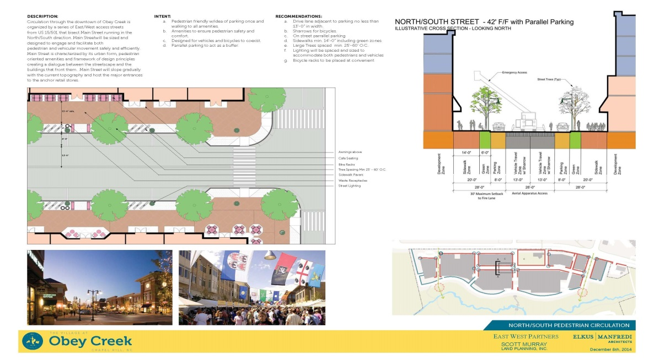

Circulation through the downtown of Obey Creek is organized by a series of East/West access streets from US 15/501 that bisect Main Street running in the North/South direction. Main Street will be sized and designed to engage and facilitate both pedestrian and vehicular movement safely and efficiently.

Main Street is characterized by its urban form, pedestrian oriented amenities and framework of design principles creating a dialogue between the streetscape and the buildings that front them. Main Street will slope gradually with the current topography that will host the major entrances to the anchor retail stores.

Proposal:
- Drive lane adjacent to parking no less than 13’-0’ in width.
- Sharrows for bicycles
- On street parallel parking
- Sidewalks minimum 14’-0’ including green zones
- Large trees spaced minimum 25’-60’ O.C.
- Lighting will be spaced and sized to accommodate both pedestrians and vehicles
- Bicycle racks to be placed at convenient locations

Obey Creek: Main Streets East/West
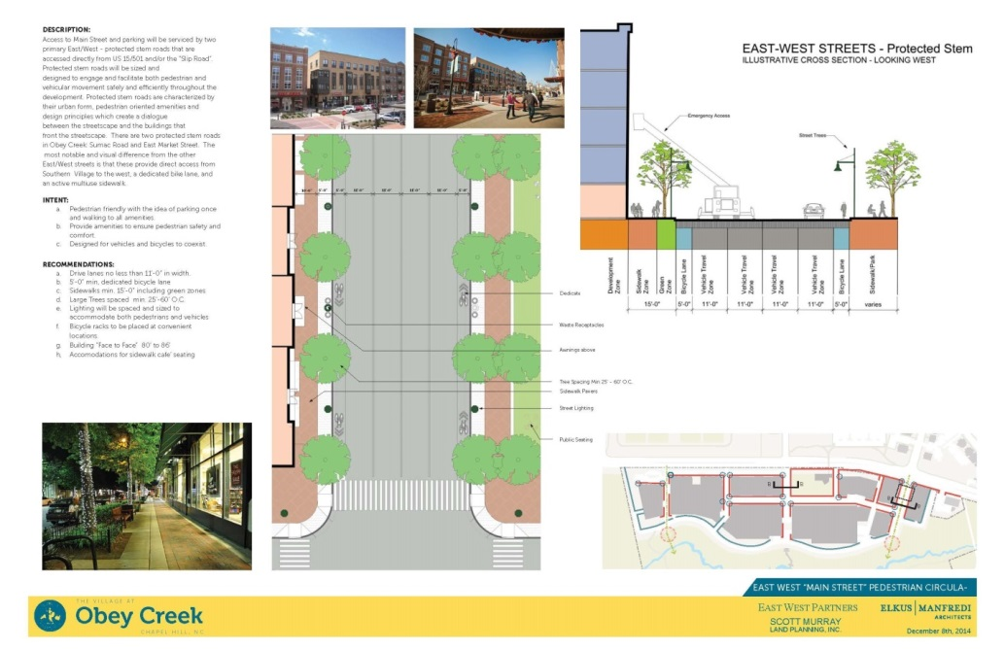

Access to Main Street and parking will be serviced by two primary East/West – protected stem roads that are accessed directly from US 15/501 and/or the “Slip Road.” Protected stem roads will be sized and designed to engage and facilitate both pedestrian and vehicular movement safely and efficiently throughout the development.

Protected stem roads are characterized by their urban form, pedestrian oriented amenities, and design principles which create a dialogue between the streetscape and the buildings that front the streetscape. There are two protected stem roads in Obey Creek: Sumac Road and East Market Street. The most notable and visual difference from the other East/West streets is that these provide direct access from Southern Village to the west, a dedicated bike lane, and an active multiuse sidewalk.

Proposal:
- Drive lanes no less than 11’-0’ in width
- 5’-0’ minimum dedicated bicycle lane
- Sidewalk minimum 15’0’ including green zones
- Large trees spaced and sized to accommodate both pedestrians and vehicles
- Bicycle racks to be placed at convenient locations
- Building “face to face” 80’ to 86’
- Accommodations for sidewalk café seating

Obey Creek: Slip Street
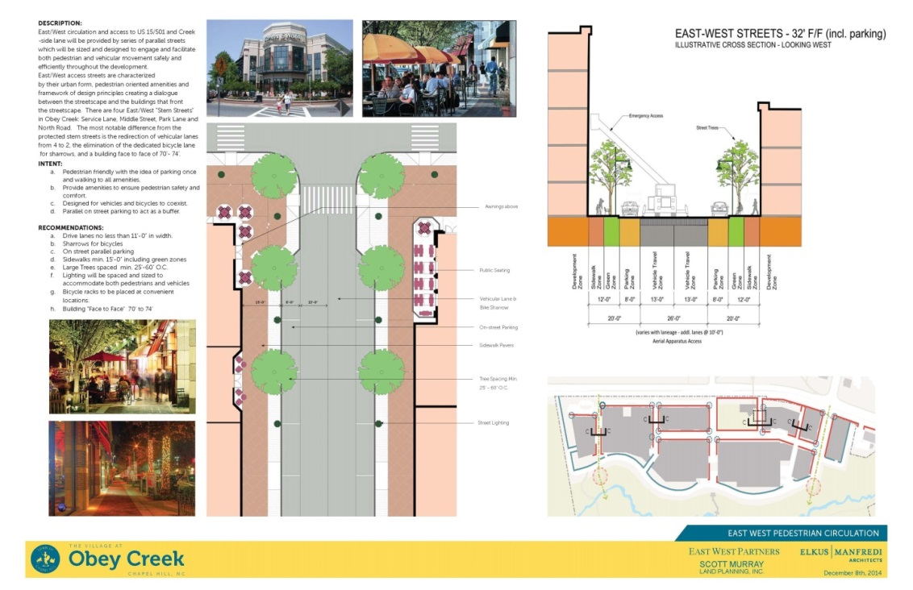

The perimeter road running parallel and continuous for the majority of the site along US 15/501 is the “Slip Road.” The slip road is used to facilitate lower speed traffic and separate it from the higher speed traffic lanes. Separating the two roads will be a continuous “green and multi-use” zone which will act as both a visual buffer and provide both pedestrian and bicycle lanes that will encourage the multi-modal environment. Diagonal parking will be provided for access to retail developments and provide an additional buffer zone between US 15/501 and the Obey Creek development.

Slip streets are characterized by their urban form, pedestrian oriented amenities and a framework of design principles creating a dialogue between the streetscape and the buildings that front the streetscape.

Proposal:
- Drive lane no less than 16’-0’
- 15’ minimum multi-use lane in the buffer zone
- On-street diagonal parking
- Sidewalk minimum 15’-0’ including green zone
- Lighting will be spaced and sized to accommodate pedestrians and vehicles
- Bicycle racks will be placed at convenient locations

Creek Side Lane
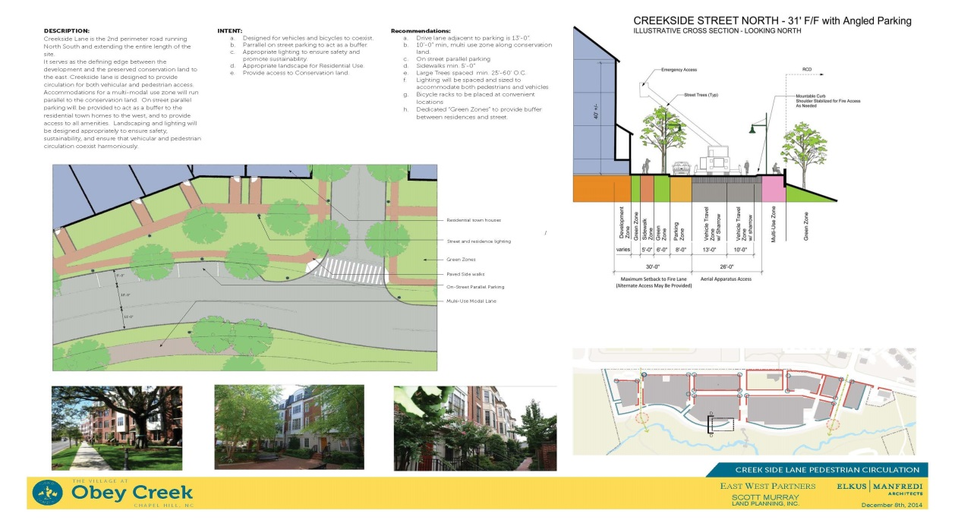
Creek Side Lane is the second perimeter road running North/South and extending the entire length of the site. It serves as the defining edge between the development and the preserved conservation land to the east.

Creek Side Lane is designed to provide circulation for both vehicular and pedestrian access. Accommodations for a multi-model use zone will run parallel to the conservation land. On-street parallel parking will be provided to act as a buffer to the residential town homes to the west, and to provide access to all amenities. Landscaping and lighting will be designed appropriately to ensure safety, sustainability, and ensure that vehicular and pedestrian circulation coexist harmoniously.

Proposal:
- Drive land adjacent to parking is 13’-0’
- 10’-0’ minimum multi-use zone along conservation land
- On-street parallel parking
- Sidewalk minimums 5’-0’
- Large trees spaced minimum 25’-60’ O.C.
- Lighting will be spaced and sized to accommodate both pedestrians and vehicles
- Bicycle racks to be placed at convenient locations
- Dedicated “green zones” to provide buffer between residences and the street

Bicycle Improvements. [OBEY CREEK: See Bicycle Circulation Information – Reference Bicycle Circulation section of the Design Guidelines document – Click here for document.]

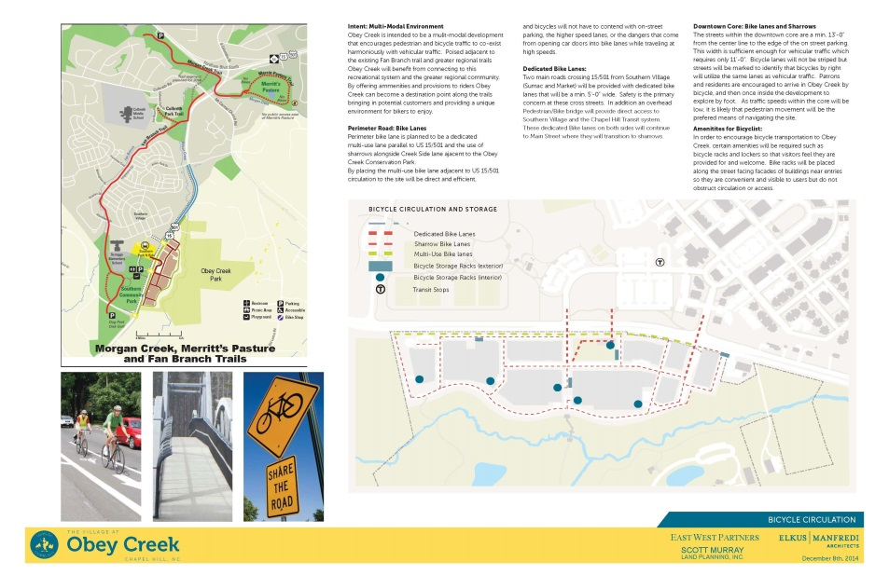

Traffic Signal System Improvements. Traffic Signal System improvements shall include the following, subject to the approval by the Town Manager and NCDOT, and should be done in conjunction with the corresponding roadway improvements – [OBEY CREEK: Include Traffic Signal System Improvements information here as necessary.]

Roadway Improvements. [OBEY CREEK: Include Roadway Improvements information here as necessary.]

Bicycle and Pedestrian Bridge. [OBEY CREEK: Include information about the Bicycle and Pedestrian Bridge as necessary.]

Fiscal Impacts.

[OBEY CREEK: Information about the fiscal impacts of the proposed Obey Creek development was provided during the October 11, 2014 Obey Creek Special Meeting. Additional information is scheduled to be provided during the January 8, 2015 Obey Creek Special Meeting.

For the staff memorandum about fiscal impacts (shared on October 1, 2014), click here and scroll to “October 1, 2014 – Council Work Meeting” – “Fiscal Report - Memorandum.” For the PowerPoint presentation (shared on October 11, 2014), click here.]

Design Standards and Public Art.

[OBEY CREEK: To be discussed – Section will be revised as necessary.]

Public Schools.

[OBEY CREEK: During the November 13, 2014 Obey Creek Special Meeting, the Council authorized the Town Manager to send a letter to the Chapel Hill-Carrboro City Schools Superintendent requesting information regarding the School Board’s interest in reserving a school site on the Obey Creek property. The letter requested a response by March 1, 2015. Upon receipt, the response will be shared with the Council.]

Open Space, Parks, and Recreation Areas.

[OBEY CREEK: This section will be revised throughout the process.]

General Provisions. The Development will incorporate open space, parks and recreation areas as an integral part of the Development. These amenities shall be coordinated and applied in a comprehensive manner across the entire Development. This section sets forth the requirements governing open space, parks and recreation areas associated with the Development.
The proposed Obey Creek concept plan includes seven (7) open space and recreation areas.

The image below can be found here on page 30.

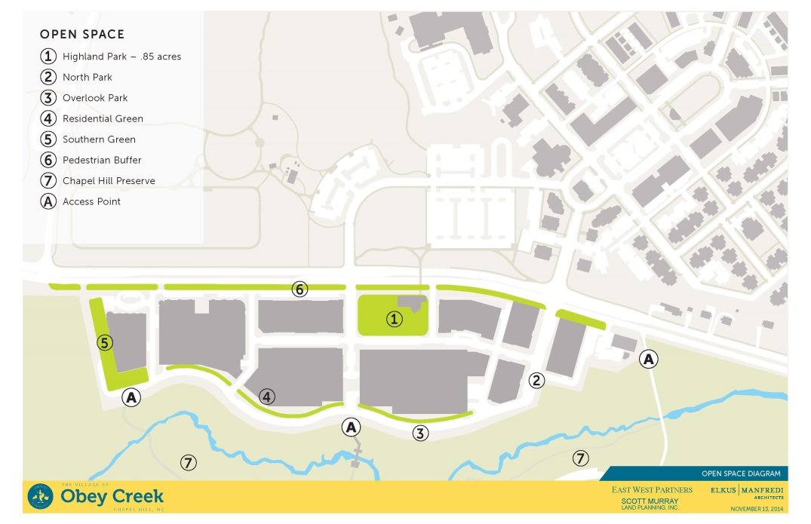

The following diagrams provide additional description about three of these areas, including Highland Park, Overlook Park, and the Wilson Creek Preservation Park.

The images below are from the Open Space section of the Design Guidelines document. – Click here for the document.

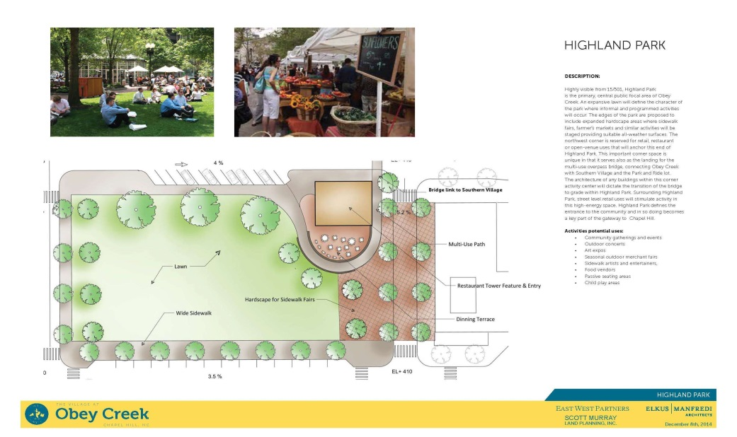
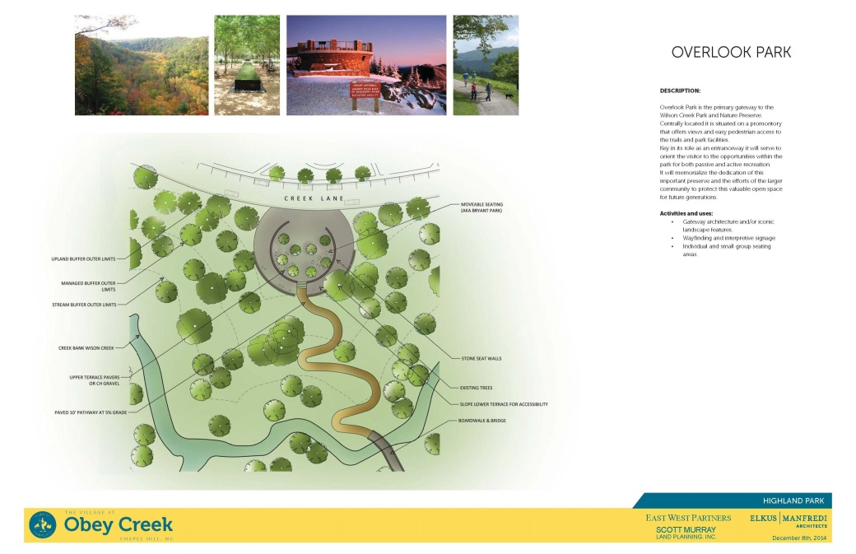
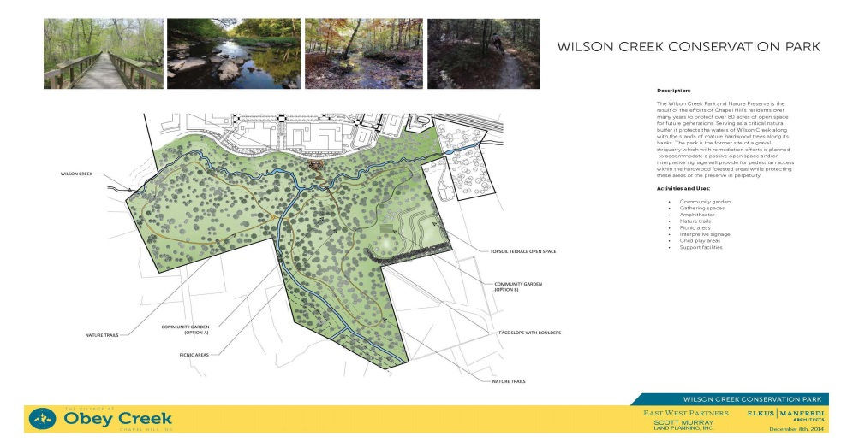

Essential Elements of the recreation space at the proposed Obey Creek development include:
- Accessible by all
- Incorporate universal accessibility
- Create public open space for community gathering
- Year-round landscape plant material for seasonal interest
- Dedicated site furniture including benches, trash receptacles, and lighting unique to specific spaces
- Preserve existing habitat
- Coordinated landscape and plant palettes
- Special lighting for public spaces
- Walking/running/bike trails are to be provided

Greenways.

[OBEY CREEK: This section will be revised throughout the process.]

The location of greenways and paths for pedestrians and cyclists on the Property will be generally consistent with [OBEY CREEK: Insert Exhibit].

All greenways shall be built to AASHTO standards for multi-use pedestrian and bicycle paths. Alternative standards can be applied in cases where the location of the greenway requires a reduced width or design modification due to building location.

The Developer Owners, the Representative or a subsequent Property Owners’ Association will maintain the greenway within the Development under the same operating conditions as Town-owned greenways with regards to maintenance, lighting, and hours of operation.

The Developer Owner shall grant a public access easement to the Town over all greenways available to the public permitting pedestrian, bicycle, and motorized wheelchair use of the greenway.

Historic and Cultural Features.

[OBEY CREEK: This section is under review by the Town Attorney and staff to revise as necessary.]

Solid Waste Management.

[OBEY CREEK: This section is under review by the Town Attorney and staff to revise as necessary.]

Stream Buffers.

[OBEY CREEK: This section is under review by the Town Attorney and staff to revise as necessary.]

Trees and Landscaping in Developed Areas.

[OBEY CREEK: This section is under review by the Town Attorney and staff to revise as necessary.]

Sedimentation.

[OBEY CREEK: This section is under review by the Town Attorney and staff to revise as necessary.]

Neighboring Lands, Compatibility, Buffers.

[OBEY CREEK: This section is under review by the Town Attorney and staff to revise as necessary.]

Noise.

[OBEY CREEK: This section is under review by the Town Attorney and staff to revise as necessary.]

Lighting.

[OBEY CREEK: This section is under review by the Town Attorney and staff to revise as necessary.]

Engineering Standard Requirements.

[OBEY CREEK: This section is under review by the Town Attorney and staff to revise as necessary.]

Annual Report.

[OBEY CREEK: This section is under review by the Town Attorney and staff to revise as necessary.]

---End of development agreement template---

Attachment A: North Carolina State Statutes – Enabling Legislation for Development Agreements

Part 3D. Development Agreements.
§ 160A-400.20. Authorization for development agreements.
(a) The General Assembly finds:
(1) Large-scale development projects often occur in multiple phases extending over a period of years, requiring a long-term commitment of both public and private resources.
(2) Such large-scale developments often create potential community impacts and potential opportunities that are difficult or impossible to accommodate within traditional zoning processes.
(3) Because of their scale and duration, such large-scale projects often require careful integration between public capital facilities planning, financing, and construction schedules and the phasing of the private development.
(4) Because of their scale and duration, such large-scale projects involve substantial commitments of private capital by developers, which developers are usually unwilling to risk without sufficient assurances that development standards will remain stable through the extended period of the development.
(5) Because of their size and duration, such developments often permit communities and developers to experiment with different or nontraditional types of development concepts and standards, while still managing impacts on the surrounding areas.
(6) To better structure and manage development approvals for such large-scale developments and ensure their proper integration into local capital facilities programs, local governments need the flexibility in negotiating such developments.
(b) Local governments and agencies may enter into development agreements with developers, subject to the procedures and requirements of this Part. In entering into such agreements, a local government may not exercise any authority or make any commitment not authorized by general or local act and may not impose any tax or fee not authorized by otherwise applicable law.
(c) This Part is supplemental to the powers conferred upon local governments and does not preclude or supersede rights and obligations established pursuant to other law regarding building permits, site-specific development plans, phased development plans, or other provisions of law. (2005-426, s. 9(a).)

§ 160A-400.21. Definitions.
The following definitions apply in this Part:
(1) Comprehensive plan. – The comprehensive plan, land-use plan, small area plans, neighborhood plans, transportation plan, capital improvement plan, official map, and any other plans regarding land use and development that have been officially adopted by the governing board.
(2) Developer. – A person, including a governmental agency or redevelopment authority, who intends to undertake any development and who has a legal or equitable interest in the property to be developed.
(3) Development. – The planning for or carrying out of a building activity, the making of a material change in the use or appearance of any structure or property, or the dividing of land into two or more parcels. "Development", as designated in a law or development permit, includes the planning for and all other activity customarily associated with it unless otherwise specified. When appropriate to the context, "development" refers to the planning for or the act of developing or to the result of development. Reference to a specific operation is not intended to mean that the operation or activity, when part of other operations or activities, is not development. Reference to particular operations is not intended to limit the generality of this item.
(4) Development permit. – A building permit, zoning permit, subdivision approval, special or conditional use permit, variance, or any other official action of local government having the effect of permitting the development of property.
(5) Governing body. – The city council of a municipality.
(6) Land development regulations. – Ordinances and regulations enacted by the appropriate governing body for the regulation of any aspect of development and includes zoning, subdivision, or any other land development ordinances.
(7) Laws. – All ordinances, resolutions, regulations, comprehensive plans, land development regulations, policies, and rules adopted by a local government affecting the development of property, and includes laws governing permitted uses of the property, density, design, and improvements.
(8) Local government. – Any municipality that exercises regulatory authority over and grants development permits for land development or which provides public facilities.
(9) Local planning board. – Any planning board established pursuant to G.S. 160A-361.
(10) Person. – An individual, corporation, business or land trust, estate, trust, partnership, association, two or more persons having a joint or common interest, State agency, or any legal entity.
(11) Property. – All real property subject to land-use regulation by a local government and includes any improvements or structures customarily regarded as a part of real property.
(12) Public facilities. – Major capital improvements, including, but not limited to, transportation, sanitary sewer, solid waste, drainage, potable water, educational, parks and recreational, and health systems and facilities. (2005-426, s. 9(a).)

§ 160A-400.22. Local governments authorized to enter into development agreements; approval of governing body required.
A local government may establish procedures and requirements, as provided in this Part, to consider and enter into development agreements with developers. A development agreement must be approved by the governing body of a local government by ordinance. (2005-426, s. 9(a).)

§ 160A-400.23. Developed property must contain certain number of acres; permissible durations of agreements.
A local government may enter into a development agreement with a developer for the development of property as provided in this Part, provided the property contains 25 acres or more of developable property (exclusive of wetlands, mandatory buffers, unbuildable slopes, and other portions of the property which may be precluded from development at the time of application). Development agreements shall be of a term specified in the agreement, provided they may not be for a term exceeding 20 years. (2005-426, s. 9(a).)

§ 160A-400.24. Public hearing.
Before entering into a development agreement, a local government shall conduct a public hearing on the proposed agreement following the procedures set forth in G.S. 160A-364 regarding zoning ordinance adoption or amendment. The notice for the public hearing must specify the location of the property subject to the development agreement, the development uses proposed on the property, and must specify a place where a copy of the proposed development agreement can be obtained. In the event that the development agreement provides that the local government shall provide certain public facilities, the development agreement shall provide that the delivery date of such public facilities will be tied to successful performance by the developer in implementing the proposed development (such as meeting defined completion percentages or other performance standards). (2005-426, s. 9(a).)

§ 160A-400.25. What development agreement must provide; what it may provide; major modification requires public notice and hearing.
(a) A development agreement shall at a minimum include all of the following:
(1) A legal description of the property subject to the agreement and the names of its legal and equitable property owners.
(2) The duration of the agreement. However, the parties are not precluded from entering into subsequent development agreements that may extend the original duration period.
(3) The development uses permitted on the property, including population densities and building types, intensities, placement on the site, and design.
(4) A description of public facilities that will service the development, including who provides the facilities, the date any new public facilities, if needed, will be constructed, and a schedule to assure public facilities are available concurrent with the impacts of the development.
(5) A description, where appropriate, of any reservation or dedication of land for public purposes and any provisions to protect environmentally sensitive property.
(6) A description of all local development permits approved or needed to be approved for the development of the property together with a statement indicating that the failure of the agreement to address a particular permit, condition, term, or restriction does not relieve the developer of the necessity of complying with the law governing their permitting requirements, conditions, terms, or restrictions.
(7) A description of any conditions, terms, restrictions, or other requirements determined to be necessary by the local government for the public health, safety, or welfare of its citizens.
(8) A description, where appropriate, of any provisions for the preservation and restoration of historic structures.
(b) A development agreement may provide that the entire development or any phase of it be commenced or completed within a specified period of time. The development agreement must provide a development schedule, including commencement dates and interim completion dates at no greater than five-year intervals; provided, however, the failure to meet a commencement or completion date shall not, in and of itself, constitute a material breach of the development agreement pursuant to G.S. 160A-400.27 but must be judged based upon the totality of the circumstances. The development agreement may include other defined performance standards to be met by the developer. The developer may request a modification in the dates as set forth in the agreement. Consideration of a proposed major modification of the agreement shall follow the same procedures as required for initial approval of a development agreement.
(c) If more than one local government is made party to an agreement, the agreement must specify which local government is responsible for the overall administration of the development agreement.
(d) The development agreement also may cover any other matter not inconsistent with this Part. (2005-426, s. 9(a).)

§ 160A-400.26. Law in effect at time of agreement governs development; exceptions.
(a) Unless the development agreement specifically provides for the application of subsequently enacted laws, the laws applicable to development of the property subject to a development agreement are those in force at the time of execution of the agreement.
(b) Except for grounds specified in G.S. 160A-385.1(e), a local government may not apply subsequently adopted ordinances or development policies to a development that is subject to a development agreement.
(c) In the event State or federal law is changed after a development agreement has been entered into and the change prevents or precludes compliance with one or more provisions of the development agreement, the local government may modify the affected provisions, upon a finding that the change in State or federal law has a fundamental effect on the development agreement, by ordinance after notice and a hearing.
(d) This section does not abrogate any rights preserved by G.S. 160A-385 or G.S. 160A-385.1, or that may vest pursuant to common law or otherwise in the absence of a development agreement.(2005-426, s. 9(a).)

§ 160A-400.27. Periodic review to assess compliance with agreement; material breach by developer; notice of breach; cure of breach or modification or termination of agreement.
(a) Procedures established pursuant to G.S. 160A-400.22 must include a provision for requiring periodic review by the zoning administrator or other appropriate officer of the local government at least every 12 months, at which time the developer must be required to demonstrate good faith compliance with the terms of the development agreement.
(b) If, as a result of a periodic review, the local government finds and determines that the developer has committed a material breach of the terms or conditions of the agreement, the local government shall serve notice in writing, within a reasonable time after the periodic review, upon the developer setting forth with reasonable particularity the nature of the breach and the evidence supporting the finding and determination, and providing the developer a reasonable time in which to cure the material breach.
(c) If the developer fails to cure the material breach within the time given, then the local government unilaterally may terminate or modify the development agreement; provided, the notice of termination or modification may be appealed to the board of adjustment in the manner provided by G.S. 160A-388(b). (2005-426, s. 9(a).)

§ 160A-400.28. Amendment or cancellation of development agreement by mutual consent of parties or successors in interest.
A development agreement may be amended or canceled by mutual consent of the parties to the agreement or by their successors in interest. (2005-426, s. 9(a).)

§ 160A-400.29. Validity and duration of agreement entered into prior to change of jurisdiction; subsequent modification or suspension.
(a) Except as otherwise provided by this Part, any development agreement entered into by a local government before the effective date of a change of jurisdiction shall be valid for the duration of the agreement, or eight years from the effective date of the change in jurisdiction, whichever is earlier. The parties to the development agreement and the local government assuming jurisdiction have the same rights and obligations with respect to each other regarding matters addressed in the development agreement as if the property had remained in the previous jurisdiction.
(b) A local government assuming jurisdiction may modify or suspend the provisions of the development agreement if the local government determines that the failure of the local government to do so would place the residents of the territory subject to the development agreement, or the residents of the local government, or both, in a condition dangerous to their health or safety, or both. (2005-426, s. 9(a).)

§ 160A-400.30. Developer to record agreement within 14 days; burdens and benefits inure to successors in interest.
Within 14 days after a local government enters into a development agreement, the developer shall record the agreement with the register of deeds in the county where the property is located. The burdens of the development agreement are binding upon, and the benefits of the agreement shall inure to, all successors in interest to the parties to the agreement. (2005-426, s. 9(a).)

§ 160A-400.31. Applicability to local government of constitutional and statutory procedures for approval of debt.
In the event that any of the obligations of the local government in the development agreement constitute debt, the local government shall comply, at the time of the obligation to incur the debt and before the debt becomes enforceable against the local government, with any applicable constitutional and statutory procedures for the approval of this debt. (2005-426, s. 9(a).)

§ 160A-400.32. Relationship of agreement to building or housing code.
A development agreement adopted pursuant to this Chapter shall not exempt the property owner or developer from compliance with the State Building Code or State or local housing codes that are not part of the local government's planning, zoning, or subdivision regulations. (2005-426, s. 9(a).)

Document: Outline of Obey Creek Development Agreement Topics – The second item under “November 13, 2014 – Council Special Meeting” - http://www.townofchapelhill.org/town-hall/departments-services/planning-and-sustainability/development/development-agreement-projects/obey-creek-/obey-creek-meeting-materials
Council Agenda Item: Glen Lennox Development Agreement (June 16, 2014) - http://chapelhillpublic.novusagenda.com/Bluesheet.aspx?itemid=2783&meetingid=292 For background information about the Glen Lennox development agreement process, visit www.townofchapelhill.org/glenlennox
East West Partners Presentation from November 13, 2014 – (Design Guidelines Document: Building Typologies Map and Types – Pages 12-16) – Dated 11/13/2014 - http://www.townofchapelhill.org/home/showdocument?id=25102
East West Partners Presentation from November 13, 2014 – (Uses at Obey Creek – Proposed Minimums and Maximums – Page 2) – Dated 11/13/2014 - http://www.townofchapelhill.org/home/showdocument?id=25102
Staff and Consultant (HNTB) Presentation from October 30, 2014 – Traffic Analysis Information – Slides 8-22 - http://www.townofchapelhill.org/town-hall/departments-services/planning-and-sustainability/development/development-agreement-projects/obey-creek-/obey-creek-meeting-materials
East West Partners Presentation from December 8, 2014 – Pedestrian Circulation Section – Pages 1-6 - http://www.townofchapelhill.org/home/showdocument?id=25403
East West Partners Presentation from December 8, 2014 – Bicycle Circulation Section – Page 8 - http://www.townofchapelhill.org/home/showdocument?id=25403
Fiscal Memorandum (Shared October 1, 2014) – Click the following link, then scroll to “October 1, 2014 – Council Work Meeting” – “Fiscal Report - Memorandum - http://www.townofchapelhill.org/town-hall/departments-services/planning-and-sustainability/development/development-agreement-projects/obey-creek-/obey-creek-meeting-materials
Fiscal Presentation (Presented October 11, 2014) - http://www.townofchapelhill.org/home/showdocument?id=24729
East West Partners Presentation from November 13, 2014 – Page 30 - http://www.townofchapelhill.org/home/showdocument?id=25084
East West Partners Presentation from December 8, 2014 – (Design Guidelines Document: Open Spaces – Pages 9-12) – http://www.townofchapelhill.org/home/showdocument?id=25403

