Questions and Responses
Obey Creek Development Agreement Negotiation Process

Last revised: January 7, 2015
Prepared by: Office of Planning and Sustainability, Town of Chapel Hill

Note: As new information becomes available, the responses may be revised. This is a process that is designed to lead to the consideration of a development agreement through negotiation.

Questions from December 8th Obey Creek Special Meeting

1. Question: What are the elevations of the buildings throughout the site?

Response: Information about the heights and building typologies that are proposed for the Obey Creek site can be found on pages 12-16 of the document titled “East West Partners Presentation” under the headline “November 13, 2014 – Council Special Meeting” or by clicking here (see page 11).

2. Question: What is being proposed for the area to the east of Wilson Creek in the conservation area?

Response: The conservation area to the east of Wilson Creek on the Obey Creek site comprises approximately 80 acres. Proposed activities and uses by East West Partners for this area include:
- Community garden
- Gathering spaces
- Amphitheater
- Nature trails
- Picnic areas
- Interpretive signage
- Child play areas
- Support facilities

Additional information, including possible locations of these activities/uses, can be found on page 12 of the document titled “East West Partners Presentation” under the headline “December 8, 2104 – Council Special Meeting” or by clicking here.

3. Question: The 3D model shows roads, some buildings, and lakes in the conservation area; will the conservation area contain these?

Response: The 3D model is a model of the proposed Obey Creek development that was prepared by East West Partners. A photograph of the model can be seen below. While the 3D model shows the current thinking about the scale and heights of buildings, the visuals for the conservation area are dated and do not show the current designs for the conservation area.

For up-to-date information about the conservation area, visit page 12 of the document titled “East West Partners Presentation” under the headline “December 8, 2104 – Council Special Meeting” or by clicking here.

Photograph of the 3D model
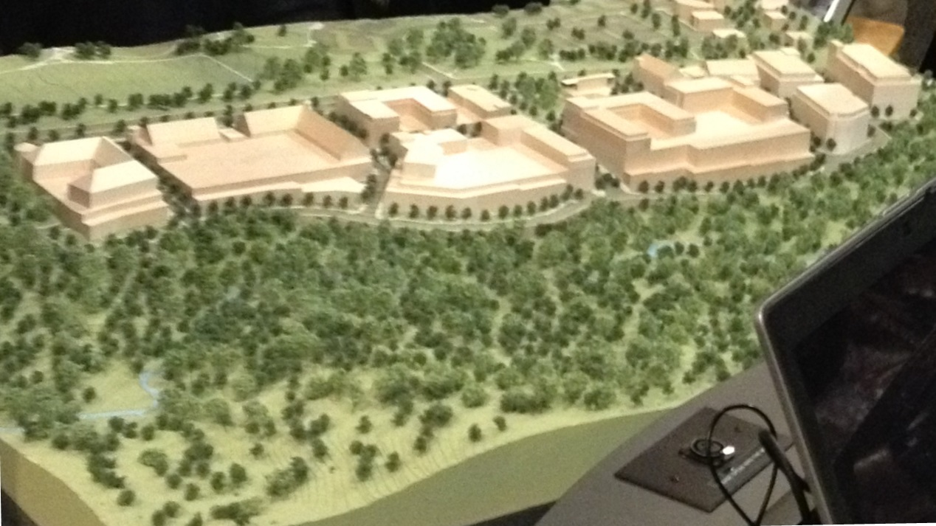

4. Question: What is the proposed use for the Town-owned strip of land within the Obey Creek site?

Response: The Town of Chapel Hill owns a strip of land that is identified in yellow in the map below. The current proposal is for the Town to consider exchanging this entire strip of land, or the portion of this strip of land west of the creek, for some or all of the 80 acres of conservation land. The Council and the applicant will have additional conversations about negotiating an exchange of property as the negotiations of the development agreement move forward.
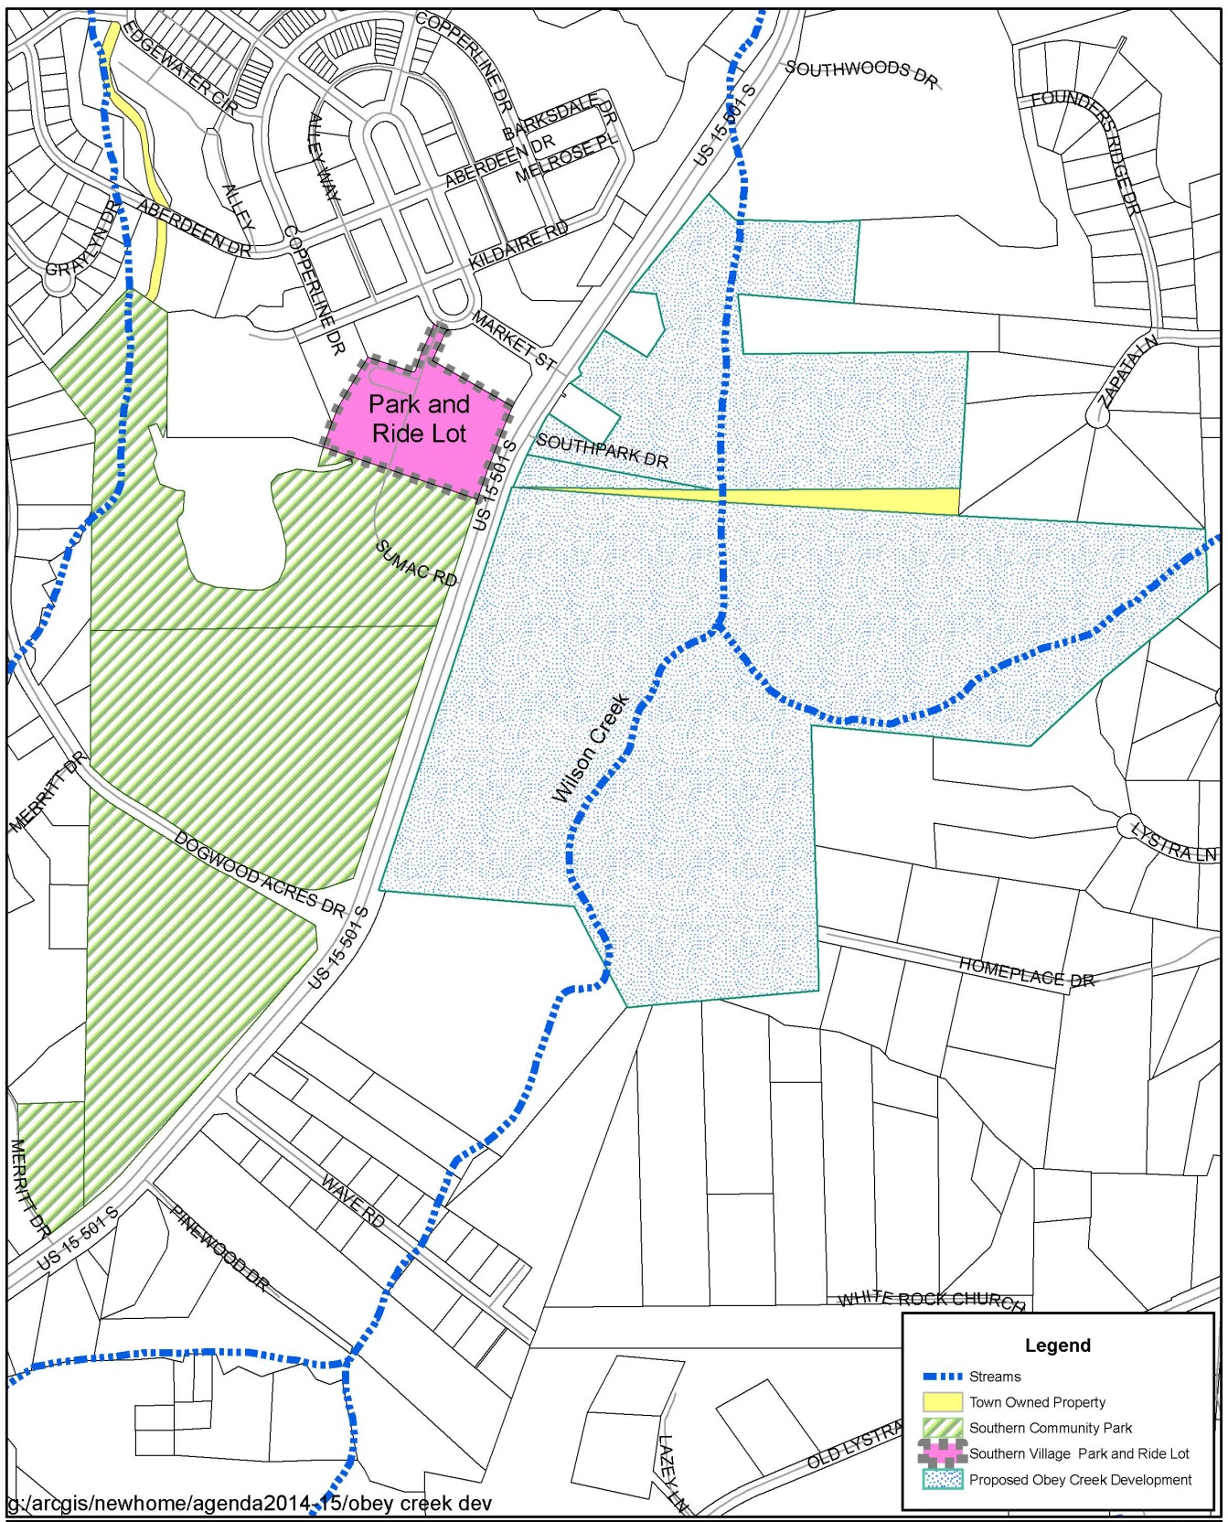
5. Question: What is the purpose of the “slip road,” and where is it located?

Response: As a part of the proposed vehicular circulation throughout the site, East West Partners is proposing the construction of a “slip road” that would run on the western edge of the site, parallel to South 15-501. The purpose of the slip road is to provide internal circulation within the site and also a frontage road for the businesses. Additional conversations will be held between the Council and East West Partners about the slip road.

Information about the current vehicular circulation proposal can be found on page 20 of the document titled “East West Partners Presentation” under the headline “November 13, 2014 – Council Special Meeting” or by clicking here.

6. What are the plans for connectivity over the pedestrian bridge?

Response: The bicycle and pedestrian bridge over South 15-501 is under discussion by the Council and the applicant and has not been designed. The bridge could provide an accessible bicycle and pedestrian connection from the Obey Creek site to the Town-owned property on the west side of 15-501.

7. What are the plans for limiting crime at the Obey Creek development through environmental design?

Response: This topic has been shared with the Police Department, and guidance received from the Police Department will be shared with the applicant.

8. What are plans for incorporating universal design into the housing units at the Obey Creek development?

Response: This topic has been shared with the applicant, and they can discuss if and how to include universal design in the Obey Creek development agreement.

General questions

9. Where can I find the most up-to-date meeting schedule for the Obey Creek process?

Response: Information about all upcoming meetings is posted on the main “Obey Creek Development Agreement Process” webpage which can be found at www.townofchapelhill.org/obeycreek

10. What is the role of the Advisory Boards/Commissions in the Obey Creek process?

Response: A development agreement is a negotiation process between an applicant (in this case, East West Partners) and the Town Council. Although the state statutes do not require review of the development agreement by Boards and Commissions, the Town Council has expressed an interest in having the Boards and Commissions be involved in the process.

The following are ways that Boards and Commissions can be involved:
How can I be involved as an individual Board member?
- Provide comments at meetings
- Email the Council

How can my Board/Commission be involved?
- Develop recommendations/feedback and submit to the Council via email or at meetings

An “Obey Creek Public Session for Advisory Boards and Commissions” was held on December 4, 2014; the purpose of the meeting was to provide an overview of the Obey Creek process thus far, to answer questions, and to provide clarification about the role of the Boards/Commissions in the process. A link to the video of the meeting can be found here.

11. Question: How can I find the most recent version of the site plan/concept plan for the Obey Creek site?

Response: The most recent version of the proposed Obey Creek site plan can be found on page 11 of the document titled “East West Partners Presentation” under the headline “November 13, 2014 – Council Special Meeting” or by clicking here.

This document also contains information about the proposed location of housing and types, building typologies, and building heights.

For links to past Obey Creek concept plans, click here.

12. Question: What is the sales data (per square feet) for the retail units in East 54?

Response from East West Partners: “We are under very strict confidentiality with our tenant sales reports at East 54 and we only get the sales figures from a few tenants. Below are the sales per foot anonymously of various tenants for the last full year of sales figures we have. I can tell you that these are all small shops and restaurants. We do not get sales info from the drug store.”
- Tenant 1 - $603/sf
- Tenant 2 - $216/sf
- Tenant 3 - $153/sf
- Tenant 4 - $212/sf
- Tenant 5 - $256/sf

13. Question: Could you provide information about benchmarks that make good mixed-use developments?

Response from East West Partners: For more information, see the “Memorandum about Mix of Uses,” developed by Roger Waldon from the East West Partners team, which can be found under the headline “December 8, 2104 – Council Special Meeting” or by clicking here.

14. Question: Is East West Partners considering including micro-incubators and entrepreneurial/innovation spaces in the development?

Response from East West Partners: “We will be designing retail spaces with varying depths that would allow for a wide range of spaces. This would allow us to include these types of small-space tenants without requiring any change of design if we were able to locate start-up or smaller businesses with interest in this type of space.”

15. Question: What is the status of the Southern Village Park and Ride Lot?

Response: The Southern Village Park and Ride Lot is currently being considered as a Town asset. A facilitated conversation with Victor Dover from the consulting firm Dover, Kohl & Partners will consider the property in the context of the southern area of Chapel Hill. This facilitated conservation is scheduled for January 22 and 23, 2015.

Most Recent Site Plan (Page 11): http://www.townofchapelhill.org/home/showdocument?id=25102
Conservation Area Information (Page 12): http://www.townofchapelhill.org/home/showdocument?id=25403
Conservation Area Information (Page 12): http://www.townofchapelhill.org/home/showdocument?id=25403
Proposed Vehicular Circulation Diagram (Page 20): http://www.townofchapelhill.org/home/showdocument?id=25102
Meeting Video – Obey Creek Public Session for Advisory Boards and Commissions: http://chapelhill.granicus.com/MediaPlayer.php?view_id=9&clip_id=2253
Most Recent Site Plan (Page 11): http://www.townofchapelhill.org/home/showdocument?id=25102
Past Obey Creek Concept Plans: www.townofchapelhill.org/town-hall/departments-services/planning-and-sustainability/development/development-activity-report/obey-creek-mixed-use-development
Memorandum about Mix of Uses: www.townofchapelhill.org/town-hall/departments-services/planning-and-sustainability/development/development-agreement-projects/obey-creek-/obey-creek-meeting-materials

