Summary Information about Area Pedestrian Bridges*
Prepared by: Office of Planning and Sustainability, December 2014

Note: Revised with “interior rail-to-rail” information on December 8, 2014.

Bridge | Length | Width | Cost  Assumes all costs | Images
Bridge over Interstate 40 (Durham) | 268 ft | 13.5 – 17 feet  12.3 feet (interior rail-to-rail) | $7 million | 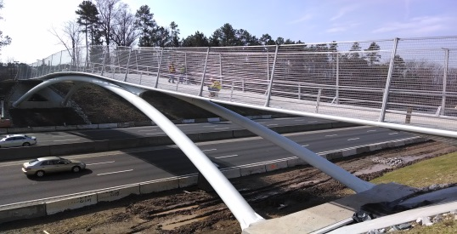
Bridge over 147 (Durham) | 195 ft | 10 feet (interior rail-to-rail) | $2 million
Bridge by Dental School  (UNC-Chapel Hill) | 175 ft | 10 feet  (inside clearance)  13 feet (exterior from face to face) | $3.2 million
Bridge over Interstate 440/Wade Ave (Raleigh) | 660 ft | 12.5 feet | $3.8 million

*Information was collected for discussion purposes from a variety of sources; some figures are estimates for general information only.

