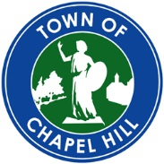
TO: Roger L. Stancil, Town Manager
FROM: Dwight Bassett, Economic Development Officer
RE: Retail potential for Obey Creek
DATE: October 3, 2014
Memorandum

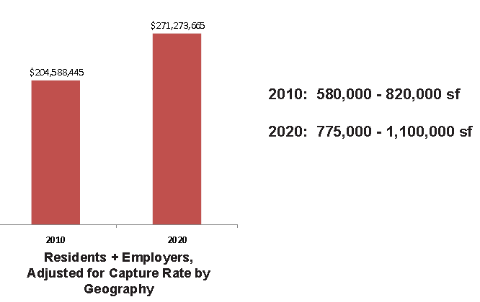
A councilmember asked the question of what might Council expect from the Obey Creek development from a retail perspective and the stores that might locate there. It seemed it might be helpful to frame the answer with our Retail Development Strategy and a guide from the International Council of Shopping Centers showing the variety of center types. Chapel Hill has limited sites within the Urban Growth Boundary that can accommodate a significant retail center (Large Neighborhood Center/ Community Center type) that also has the market to support and is not competing with an existing center.

Chapel Hill Retail Market

In 2011 the Town completed a Retail Development Strategy as an implementation step to the 2008 adopted Economic Development Strategy and as a follow-up to the 2009 Retail Market Analysis. These reports can be found on the Town web site at:

Retail Market Analysis – (2009)

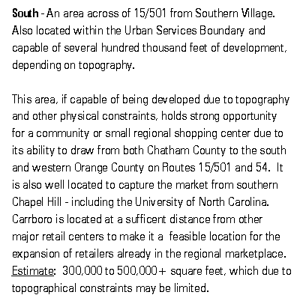
Retail Development Strategy – (2011)
The Retail Market Analysis showed that we were losing over 35% of our retail market potential. It did not help to guide the Economic Development Committee in a specific direction from a growth perspective. Staff decided it might be of benefit to add back into the market analysis, land use opportunities to create a Retail Development Strategy. As a part of the consultant presenting the findings of this report, we also brought in a former executive from Simon Properties to share information about retail development and locations.

The Retail Development Strategy showed that Chapel Hill have (2011) market potential for 500,000 +/- square feet and future potential (2020) of 1,000,000 +/- square feet. The bulk of the unmet demand (at a .75% capture rate) was in south Chapel Hill.

Obey Creek is perhaps Chapel Hill’s last opportunity to attract a significant amount of retail in a single, concentrated location (Large Neighborhood Center/ Community Center type). The area to the south of Town can capture the rapid residential growth in northern Chatham County in addition to the Chapel Hill and Carrboro retail sales currently flowing to Durham County. Opportunities for retail growth on the eastern side of Town and 15-501 corridors north of Town are limited as Durham County has already captured these markets just across the County lines in the Southpoint Mall area and the New Hope Commons / Patterson Place areas. Areas on the west side of Carrboro and Martin Luther King Jr. Blvd. corridor, north of Town, are unlikely to attract any significant retail due to the limited growth potential in the rural buffer.
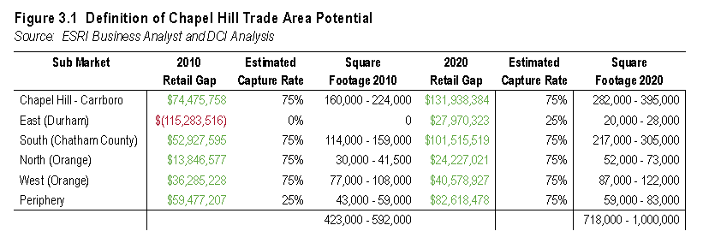
Due to the underserved Chapel Hill and Carrboro markets and the rapid residential growth in northern Chatham County, the Obey Creek site will be appealing to large format hard goods retailers, such as Target, and full service grocers, such as Harris Teeter or Publix. With one or two of these anchor tenants, the project will be appealing to slightly smaller, Jr. Anchor tenants, such as TJ Maxx, Total Wine, Bed Bath & Beyond, etc. With this type of anchoring presence to the retail, then the project will be able to attract an additional 75,000+ square feet of smaller, potentially locally owned, shops and restaurants which are necessary to round out a vibrant destination retail center.

Types of Shopping Centers
